**Experiment No. 9**

**Aim**: Implement and evaluate Frequent Pattern Mining Algorithms using languages like JAVA/python/R.

**Theory :**Solution: Frequent Pattern Mining is an essential task in data mining and finding frequent item sets in a transactional dataset. In this example, I&#39;ll show you how to implement and evaluate the Apriori algorithm, one of the most popular algorithms for frequent pattern mining, using Python.

First, make sure you have Python and the required libraries installed:

1. Python 3.x

2. pandas (for handling data)

3. mlxtend (for Apriori algorithm implementation)

You can install the required libraries using pip:

pip install pandas mlxtend

Now, let&#39;s implement the Apriori algorithm and evaluate it using a sample dataset:

**Step 1**: Create a Data Set.

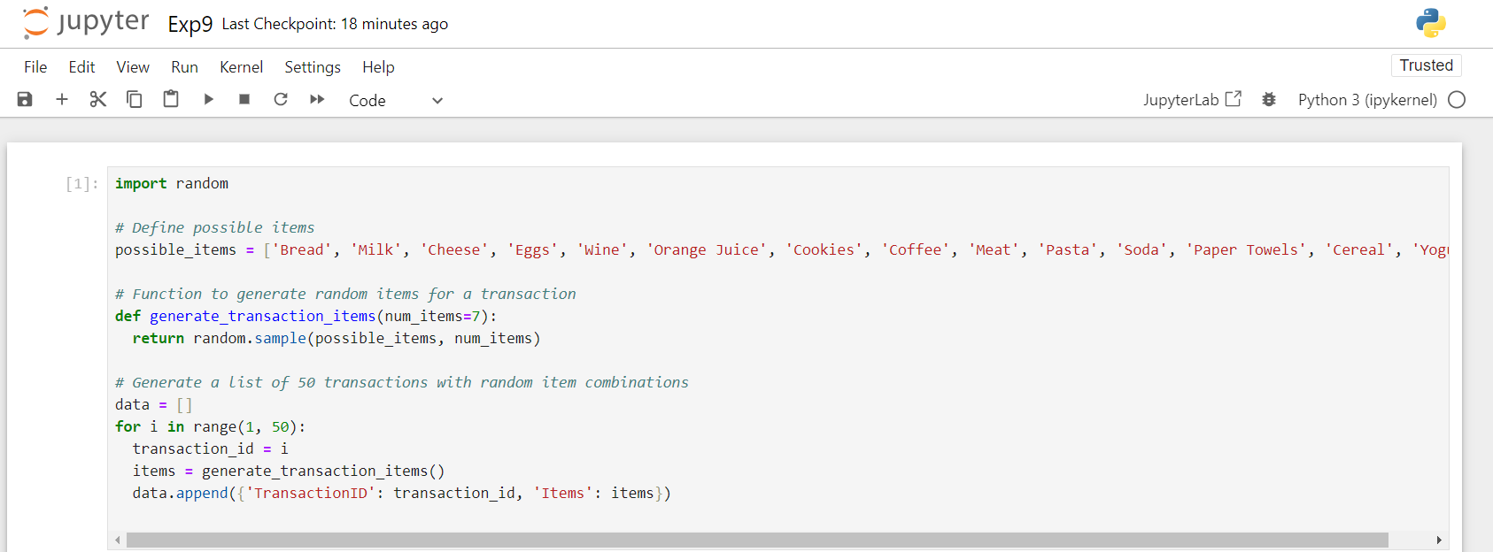

**Step 2:** Import Libraries:



**Step 3:** Convert to data frame:

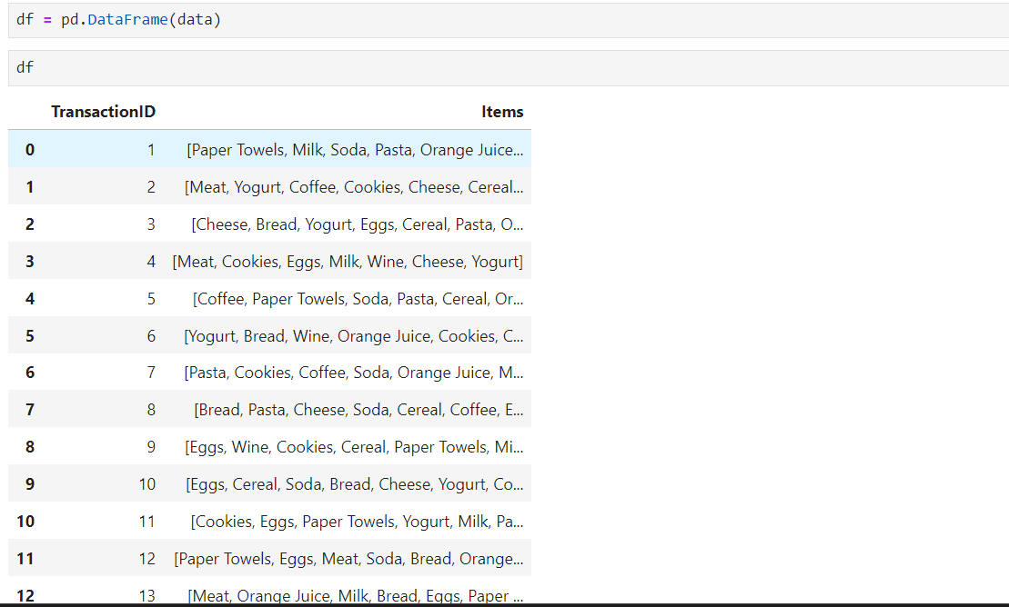

**Step 4 :**One-hot encode the DataFrame:  
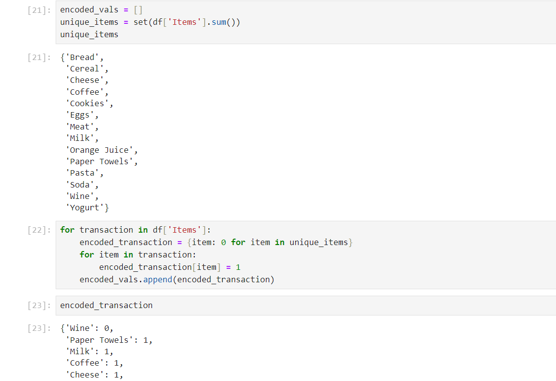

**Step 5:** Convert the encoded list into Dataframe:

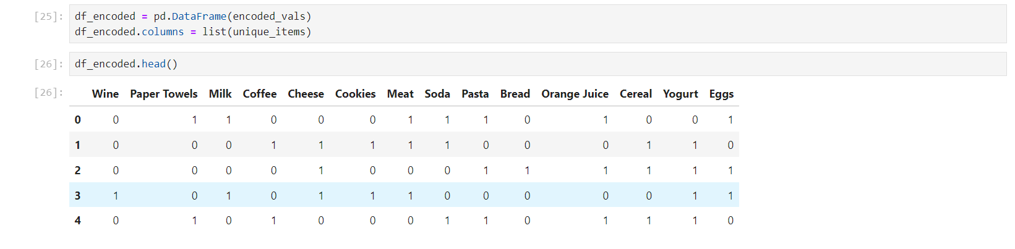

**Step 6 :**Convert values to 1 or 0 (might be handled differently in the original code)

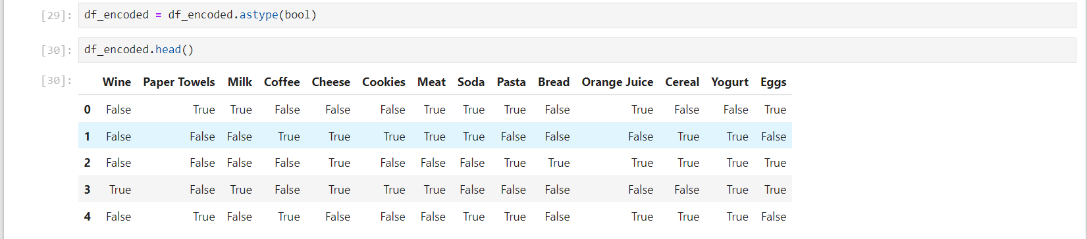

**Step 7:**Find frequent itemsets (function name or parameters might vary)

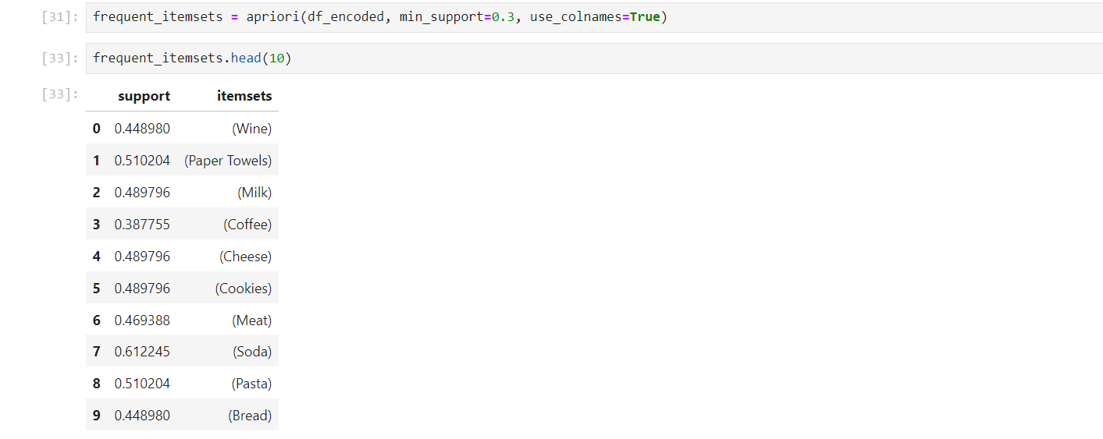

**Step 8:** Generate association rules (function name or parameters might vary)

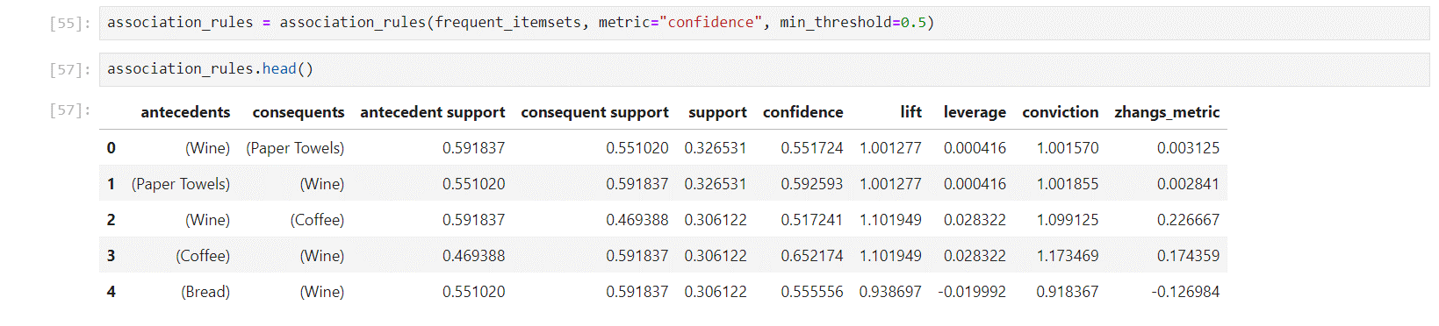

**Conclusion:**Hence we Implemented Frequent Pattern Mining Algorithms using python.